# Flash Guide

## Flashing the device

If you successfully followed “Project Setup.pdf” guide, you have already created all Build Targets:



By executing “all” build target, code will be compiled, linked and stored to the build output directory specified in makefile. Build output looks like this:

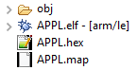

At the top level there are tree files:

1. .elf file – final executable file which will be flashed to the device, contains everything necessary for flashing and debugging
2. .hex file – final executable file in rawer format than .elf file
3. .map file – contains information of all memory regions, variable locations etc.

Before continuing, please execute the “all” build target if you haven’t yet done so.

In order to flash the device, first a Run configuration must be configured:

1. Open “Run Configurations…” window

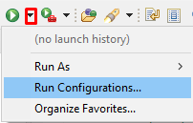

1. Double click on “STM32 C/C++ Application” and a new configuration will be created under it. There are few things that need to be configured:
   1. “Name” – optional
   2. “Project” – must be selected (if isn’t already) from “Browse…” option – root directory
   3. “C/C++ Application” – must be selected (if isn’t already) from “Browse…” option – elf file generated from the build
   4. “Disable auto build” from “Build (if required) before launching” section selected
   5. Click “Apply” and then “Run” – this will start the flashing process which can be followed in console area

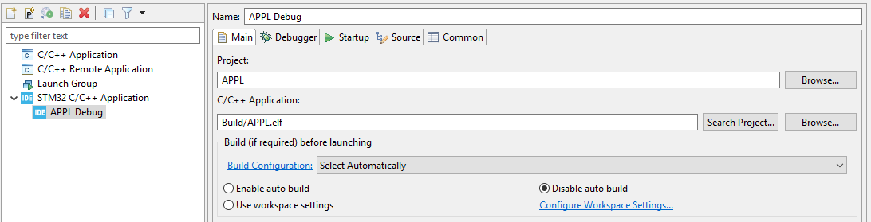

1. Next time, in order to perform flashing procedure, you can simply choose the configuration from previous build like so or simply clicking on green play button:

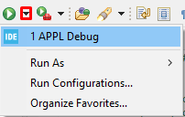

There are many more options with the Run Configuration which can be browsed when configuring it in other tabs. These options were left as default values and are not a part of this flash guide, at least not at the moment.

## Possible issues

### No ST-LINK detected

In case this error message pops up, follow solution on this [link](https://community.st.com/s/question/0D53W00000nbFQUSA2/no-stlink-detected-stm32cubeide-161-win7-solvedcubeprogrammer-can-see-and-program-the-board-fine-cubeide-wont-see-the-stlink-probe). Make sure to download exactly version 1.0.24 of libusb even if newer versions exist.